**Transcript**

## 1. Multiple criteria

Great work on filtering numbers! Our SQL skills are growing fast. Next up, we will look at how to filter with multiple criteria.

## 2. Multiple criteria

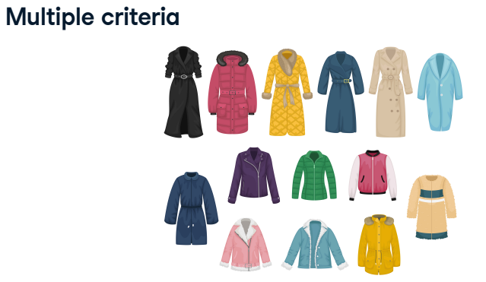There will often be the case that we have more than one criteria we'd like to meet. Looking again at our favorite coats, perhaps we want narrow down our choices to coats

## 3. Multiple criteria

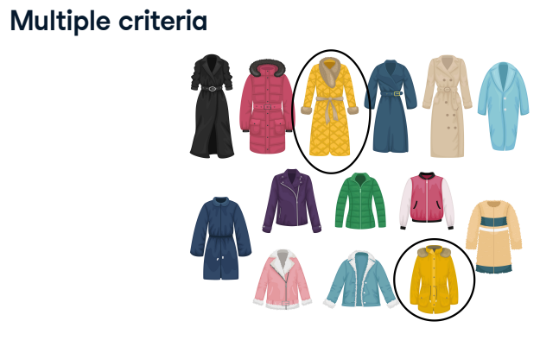that are yellow

## 4. Multiple criteria

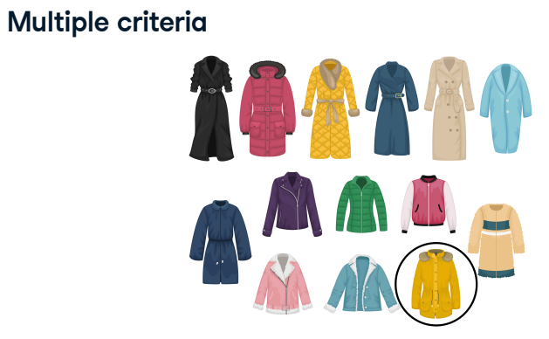and shorter in length.

## 5. Multiple criteria

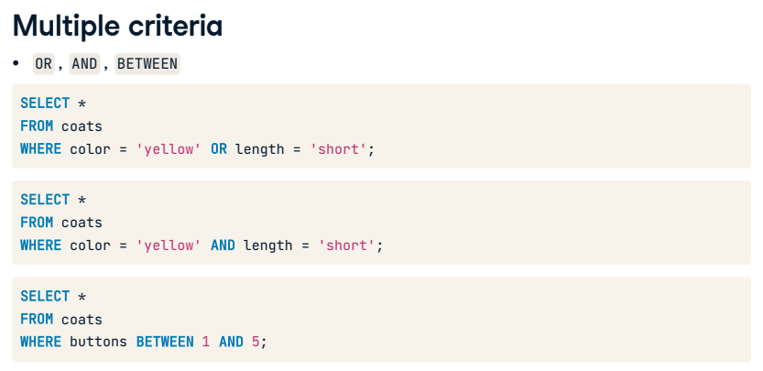We will be learning about three additional keywords that will allow us to enhance our filters when using WHERE by adding multiple criteria. These are OR, AND, and BETWEEN. In the context of our coats, we could look at coats where the color is yellow or the length is short, or we could filter for coats where both criteria are true. We can also look for coats that have between one and five buttons.

## 6. OR operator

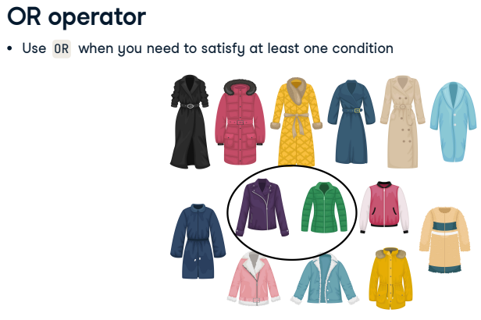The first keyword we will look at is the OR operator. OR is used when we want to filter multiple criteria and only need to satisfy at least one condition. Perhaps we want to select green or purple coat options as an example.

## 7. OR operator

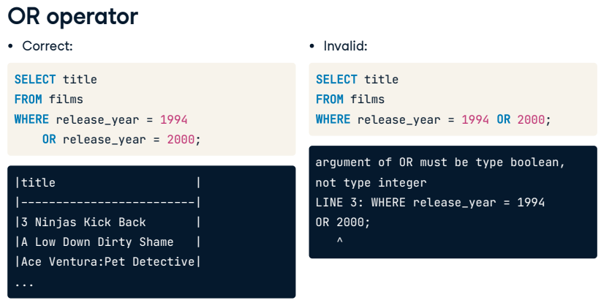In SQL, we combine OR with WHERE to achieve this type of filtering. Here is an example using the films database. The query on the left returns all films released in either 1994 or 2000. Note that we must specify the field for every OR condition, so the query on the right is invalid. That query hasn't specified what field or operator should be associated with the year 2000.

## 8. AND operator

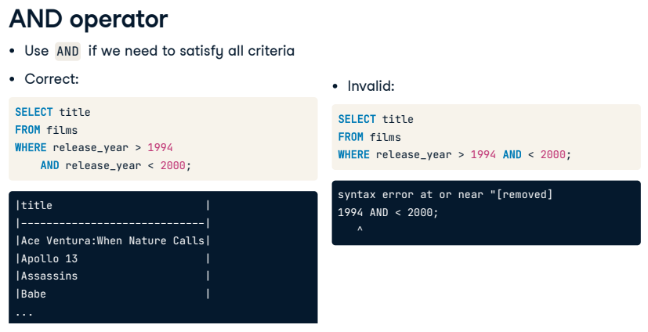If we want to satisfy all criteria in our filter, we need to use AND with WHERE. For example, this query gives us the titles of films released between 1994 and 2000. We need to specify the field name separately for every AND condition as with OR.

## 9. AND, OR

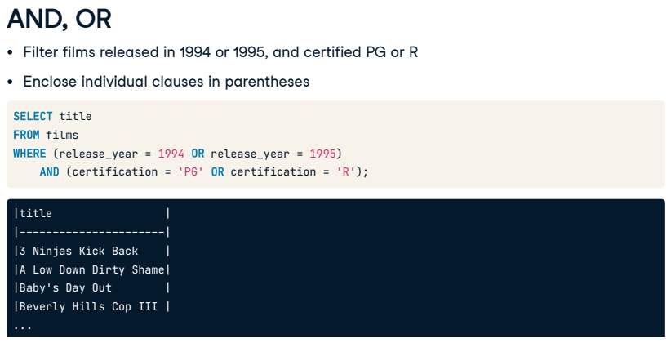Let's kick it up a notch. We now want to filter films released in 1994 OR 1995, AND with a certification of either PG or R. Thankfully, we can combine AND and OR to answer this question. If a query has multiple filtering conditions, we will need to enclose the individual clauses in parentheses to ensure the correct execution order; otherwise, we may not get the expected results.

## 10. BETWEEN, AND

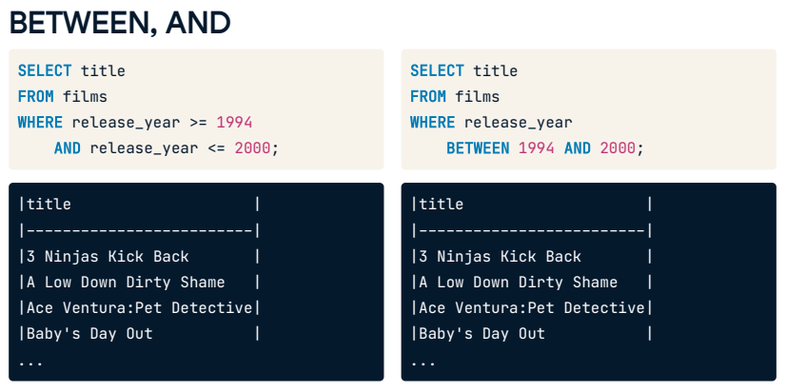As we've learned, we can use this query to get titles of all films released in and between 1994 and 2000. Checking for ranges like this is very common, so in SQL the BETWEEN keyword provides a valuable shorthand for filtering values within a specified range. This second query is equivalent to the one on the left. It's important to remember that BETWEEN is inclusive, meaning the results contain the beginning and end values.

## 11. BETWEEN, AND, OR

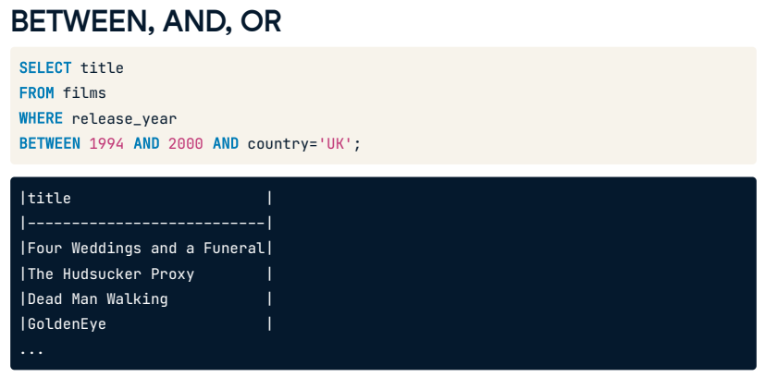Like the WHERE clause, the BETWEEN clause can be used with multiple AND and OR operators, so we can build up our queries and make them even more powerful! For example, we can get the titles of all films released between 1994 and 2000 from the United Kingdom.

## 12. Let's practice!

Have a go at using BETWEEN, AND, and OR on the films database.

## Exercise

# Using AND

The following exercises combine AND and OR with the WHERE clause. Using these operators together strengthens your queries and analyses of data.

You will apply these new skills now on the films table.

## Instructions

* + Select the title and release_year for all German-language films released before 2000.
  + Update the query from the previous step to show German-language films released after 2000 rather than before.
  + Select all details for German-language films released after 2000 but before 2010 using **only** WHERE and AND.

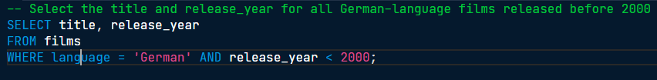

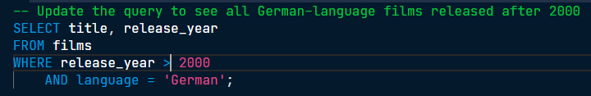

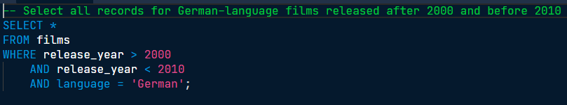

Great work! Combining conditions with AND will prove to be very useful when we want our query to return a specific subset of records.

## Exercise

# Using OR

This time you'll write a query to get the title and release_year of films released in 1990 or 1999, which were in English or Spanish and took in more than $2,000,000 gross.

It looks like a lot, but you can build the query up one step at a time to get comfortable with the underlying concept in each step. Let's go!

## Instructions

* Select the title and release_year for films released in 1990 or 1999 using only WHERE and OR.

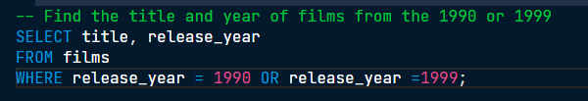

* Filter the records to only include English or Spanish-language films.

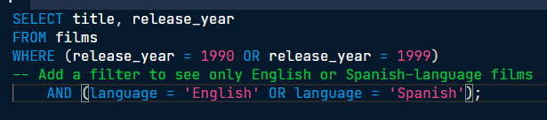

* Finally, restrict the query to only return films worth more than $2,000,000 gross.

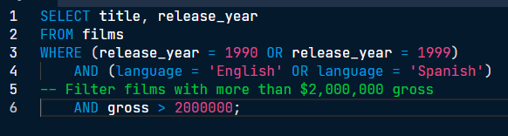

Amazing work! Some of these queries were pretty complex. Any Die Hard fans out there?

## Exercise

# Using BETWEEN

Let's use BETWEEN with AND on the films database to get the title and release_year of all Spanish-language films released between 1990 and 2000 (inclusive) with budgets over $100 million.

We have broken the problem into smaller steps so that you can build the query as you go along!

## Instructions

* Select the title and release_year of all films released between 1990 and 2000 (inclusive) using BETWEEN.

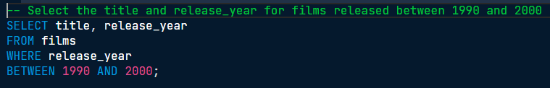

* Build on your previous query to select only films with a budget over $100 million.

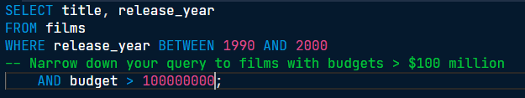

* Now, restrict the query to only return Spanish-language films.

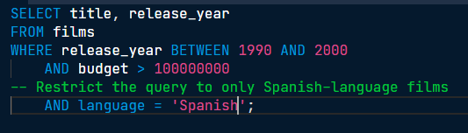

* Finally, amend the query to include all Spanish-language *or* French-language films with the same criteria.

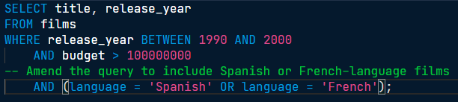

Superb! Using WHERE with a combination of AND, OR, and BETWEEN is an efficient way to query a desired range of values.